

**Senior Design Project Report**

**EEE 499A**

**Title: Air quality monitoring for detecting pollutants with Drone**

**Submitted By**

Raisa Faruqui 1430962643

Amzad Hossain 1620599045

Meratun Junnut Anee 1620527043

Sabahat Bushra 1611955010

**Supervisor**

Mohammad Ashrafuzzaman Khan (Azk)

Assistant Professor

Department of Electrical and Computer Engineering

**NORTH SOUTH UNIVERSITY**

**Abstract**

Dhaka is the capital as well as fastest growing city in Bangladesh. As an introduction to the world it is overpopulated, traffic congested and polluted. It is ranked 21st in most polluted city in the world and Bangladesh became 1st in world most polluted country in 2019. There has been little systematic research on air pollution of Dhaka resulting from traffic. There have been some estimations of emission from different sectors (e.g. transport, industry, residential etc.). The pollutants in consideration were NOx, SOx, CO, CO2, PM2.5, and PM10 etc. The average concentrations are 271.5, 101.3, 30, 24, 12 microgram/m3 and1.88 ppm respectively. The particulate matter (PM10 and PM2.5) exceed the Bangladesh air quality standards and those prescribed under the World Health Organization air quality guidelines at an alarming level. Monitoring systems are needed to obtain information about particulate matter (PM) concentrations and to make such information accessible to the public. Small, low-cost, optical sensors could be used to improve the spatial and temporal resolution of PM data. Therefore, the contribution of particulate matter occurring many hazardous diseases like vomiting respiratory tract illness different types cancer coronary diseases and so on is increasing day by day. This paper uses the traffic and air quality data which have been estimated, collected and analyzed by previous studies, reports and researches. It attempts to summarize and depict the research results on air pollution of Dhaka (particular area), with brief description of the transport system and the area

**Table of Content**

Abstract……………………………………………………………………………………2

Table of contents…………………………………………………………………………3

Background and Motivation……………………………………………………………..4-5

Project Goal……………………………………………………………………………….5

1. Introduction…………………………………………………………………………….5-8

* 1. Project Details………………………………………………………………5-8

2. Methodology……………………………………………………………………………8-11

2.1 Existing Solution…………………………………………………………….8-10

2.2 Proposed Solution………………………………………………………......10-11

3. Technical Design………………………………………………………………………12-17

3.1 Work Flow diagram and explanation...........………………………………12

3.2 Block Diagram……………………………………………………………….13

3.3 Work Breakdown table……………………………………………………..14-16

3.4 Financial requirements……………………………………………………..16-17

4. Features with Design and Explanation................................................................17-29

4.1 Software requirements……………………………………………………..17

4.2 Hardware Description………………………………………………………18-26

4.3 Circuit Diagram (Sensor)……………………………………………………27

4.4 Circuit Layout…………………………………………………………………28

4.5 Circuit Diagram (Drone)……………………………………………………...29

5. Result and Discussion…………………………………………………………………30-34

5.1 Steps of Drone building………………………………………………………30-31

5.2 Discussion……………………………………………………………………..32

5.3 Future Work……………………………………………………………………32-33

5.4 Acknowledgement…………………………………………………………….33-34

Conclussion…………………………………………………………………………………35

**Background and Motivation:**

**Background:**

The materials needed to build the drone are extremely complex composites. These materials are very lightweight and designed in such a manner that it absorbs the vibration produced which helps in decreasing the noises. Drones can be made in many different sizes. The larger ones are used in military purposes and the one next among the larger size drones are our one with fixed rotors which are best to cover large sections of land, for geographical and environmental surveying purpose. The radar technology works behind the GNSS feature of the drone. The ground station remote controller receives signal through the radar regarding its flight.

The science behind using the mind strength to pilot the drone is a combination of neuroscience and computer science. The technology is brain-computer interfaces (BCI) which is a part of a much larger field of study. When we think about something the neurons in our brain sends electrical signals to one another and through BCI technology wearing electroencephalography (EEG) systems and a sensor attached in the drone we can detect and interpret these signals. BCI technology reads the brain’s electrical

**Motivation:**

One of the world’s greatest issues is air pollution for which food security and people’s life both are at risk. In simpler terms our project is an environmental drone. This day’s drones are used for multifunctional purposes and we chose to do this because in context of our country as well as the whole world we should contribute in taking good care of our environment. Air pollution poses a global environmental health risk. It causes the death of billions every year and damages about billions of crops which could have been feed to the poor. The effect of air pollution on the environment and the people on this earth is extremely hazardous. Increasing level of air pollution causes damage to plants and buildings too.

An air quality index (AQI) is issued by the government of every country. It is a way of the governments of the different country to share with the citizens about the latest condition of the air pollution. It gives a measure of how polluted the air is now (through real-time technology) of a certain place in a country and it also forecasts on how polluted it may become. Poor air quality has severe effects on human health especially people working outdoor might develop lung cancer and respiratory diseases such as emphysema.

Thus, these are the thoughts that made us do this project of ours. Countries with higher AQI are at greater risk and Bangladesh ranks in at the 168th position at the Environmental Performance Index for Air Quality with a higher AQI among 179 countries. According the Department of Environment (DoE) in Bangladesh the AQI is higher because of the following pollutants: Particulate Matter (PM10), Particulate Matter (PM2.5), Nitrogen dioxide (NO2), Sulphur dioxide (SO2), Carbon Monoxide (CO) and Ozone (O3)

**Project Goal:**

We started off with the idea of a multifunctional drone with the ability of the drone to be able to detect the air pollutants present and measuring and providing data of the air pollution density, when it is above a threshold value. However, the goal of our project changed in during the project development phase. Our initial idea also included our drone to be controlled with our mind power. A major feature of our system laid in being controlled (turning it on and off) making it fly from the ground to a certain height and down using our mind power. Although even if we couldn’t demonstrate it but we did do some researches on the BCI technology through which this could be in future initiated and in do some further research on it in the following course 499B. Also, in 499B we might further work on with the statistical analysis using open CV.

# 1 Introduction

**1.1** **Project Details:**

Drone is an aerial quadcopter with four rotors. It is also known as unmanned aerial vehicle, UAV. When surveying landscapes highly accurate drone navigation is very crucial. Drones were mostly used in for military purposes because they can fly as long as the past few years drone has been more used for recreational purposes and commercial and motion picture filmmaking. UAV drones are most of the time assembled with different technology such as GPS, laser (for commercial and military purposes) and with infrared cameras too.

Our project is a multifunctional drone, which is used to monitor and record the pollution density in the air in a certain area. This multifunctional drone will autonomously drive along and collect data for analysis of the pollution density in certain areas of Dhaka city in Bangladesh. When surveying landscapes highly accurate drone navigation is very crucial. So this multifunctional drone works as it navigates itself to the designated location with the help of the GPS technology equipped in it up to a different predetermined height every hour and from there detect the pollution density (the concentration of all the air pollutants present), only when the value is above the recommended threshold density, and then finally flies back down to the place from where it took its flight off on the ground.

Different sensors for different purposes are assembled in drones. For instance, in order to detect the place the drone is navigating specific position and movement sensors are used which give us the particular information. The system is assembled with the pollution detecting sensor in it for the actual purpose, so that we can measure the excessive pollution above the threshold value. The quadcopter is also designed to take photos and videos of the certain location it would monitor so that later after analyzing the data certain actions could be taken place considering the photos and videos made, in order to lower the risk of pollution in that area. For instance if the area monitored has a high pollution density and then from the pictures taken or the video made we can know whether that area is a busy road where we can limit the causes for increasing pollution or whether it is a quieter area where different initiative can be taken to lower the risk. The pollution detector sensors used are the gas sensors: MQ135, MQ2 and MQ7. Also high precision particulate matter (PM10 and PM2.5) dust sensors are used. We plan to statistically analyze our data collected from the drone using open CV and later plan to compare those data with more administrative values.

We also plan to add mind control system in this multifunctional drone. Drones are controlled by remote ground control systems and we planned to work on making it navigate with our mind power strength using the BCI technology. The BCI technology also known as the brain computer interface will help us turning on and off the drone i.e. flying the drone from the ground to a certain height in air by our mind strength.

**Uses of drones:**

* Remote sensing
* Agricultural purposes
* Commercial aerial surveillance
* Commercial and motion picture filmmaking
* Oil exploration
* Mineral exploration
* Disaster relief
* Real estate and construction
* Recreational use
* Military purposes
* Security
* Gas exploration
* Defending Wildlife
* Sustaining renewable energy

Our project involves multifunctional drone which is apparently a quadcopter. Quadcopter is a multi-rotor drone. Multi-rotor drones are used in aerial photography, aerial video inspection, for agricultural surveying, security purposes and many more. Advantages of a multi-rotor drone lays in its easy manufacture as well as those are inexpensive in building. There are tricopters, quadcopters, hex copters and octocopters too. However multi-rotor drone just not have advantages, but they do have disadvantages.

**Advantages:**

* These drones are easy to control and land vertically.
* Multi-rotor drones are very stable
* Cheaper to build

**Disadvantages:**

* However, gravity and stabilizing in the air is difficult. Most of the drone’s power gets loss in it.

**Causes of air pollution:**

Bangladesh is a highly polluted country. There are many reasons that contribute to air pollution:

* Harmful gases emitted by the industries.
* Emission of harmful gases from the vehicles
* Commercialization of cities (cutting down trees)
* Combustion of fossil fuels in industries.

The air pollutants causing the harm:

* Particulate matter (PM10)
* Particulate matter (PM2.5)
* Carbon dioxide(CO2)
* Carbon monoxide(CO)
* Nitrogen oxides(NOX)
* Sulfur dioxide (SO2)
* Ozone (O3)

**Effects of air pollution:**

* Environment: Air pollution has a huge impact on plant evolution. They prevent photosynthesis because of the impure air. Also because of the combustion of fossil fuels acid rains taken place.
* Global Warming: Global warming and climate change occurred due to the increasing air pollution. The fact that there is an abundance of carbon dioxide in the air (which is a greenhouse gas) is harmful for the nature. The presence of excessive amount of greenhouse gas is one of the causes of the greenhouse effect. Greenhouse gases are good for the nature as they absorb the infra-red radiation, but excessive amount of these greenhouse gases is harmful.
* Human health: Continuous exposure to air pollutants causes allergies, major cardiovascular diseases, lung damages and respiratory diseases as well. Excessive air pollution causes major health deterioration of human.

# 2. Methodology

**2.1 Existing Solution:**

1. **Amel (UAV)**

It is an Algerian design of drone. Its design and manufacture is Star Aviation. It took its first flight at 2013. Algerian Air force is the primary user of this drone. From 2013 to present it gives it services.

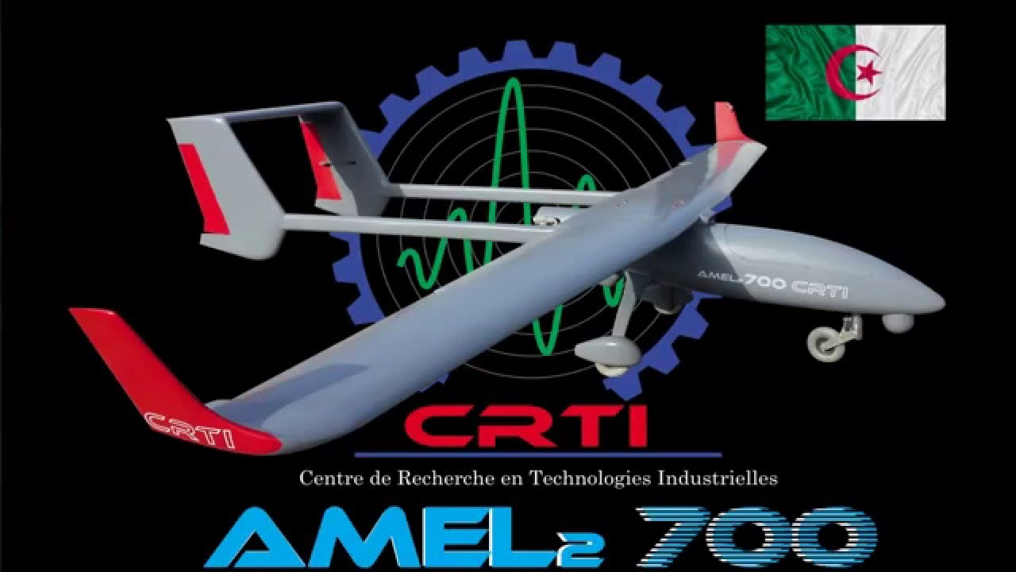

**Fig:1 Amel(UAV).**

1. **RedEdge-MX Dual Camera Imaging System**

This system has10-band multispectral solution incorporates the RedEdge-MX sensor and the new RedEdge-MX Blue, which features a new group of five filters including a coastal blue band and two new red edge bands. This is mainly designed to ensure easy data capture for research and drone/satellite comparisons, including applications such as shallow-water environmental monitoring and detailed chlorophyll efficiency analysis. To do comparison between satellite and drone data for efficient trend modelling ,The Dual Camera Imaging System is the first MicaSense product to capture the Landsat 8 and Sentinel satellite bands, allowing for direct data.The complete package includes an integrated quick mounting bracket and wiring harness for swift, easy attachment to DJI drones.

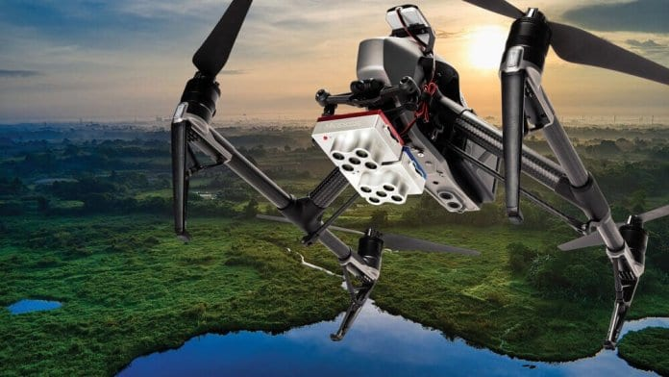

**Fig:2 RedEdge-MX Dual Camera Imaging System Drone.**

1. **Weather Sensors Aid Drone-Based Atmospheric Studies**

This project showed how UAV (unmanned aerial vehicle) manufacturers and researchers have used the company’s ultrasonic weather sensors to aid in drone-based atmospheric research and meteorological studies. Anemoment’s [TriSonica Mini Wind & Weather Sensor](https://anemoment.com/features/" \l "trisonica-mini" \t "_blank) is the world’s smallest and lightest 3D ultrasonic anemometer, providing high accuracy wind speed, direction, temperature, humidity, pressure, tilt, and compass data. Different companies selected this system for atmospheric research and meteorological studies.

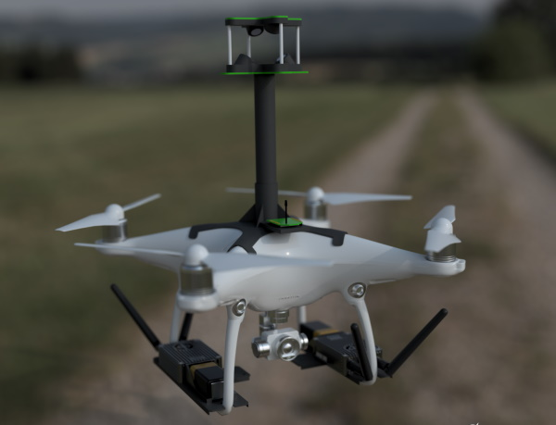

**Fig:3 Drone-based atmospheric research and meteorological studies.**

1. **Drone-Based Electroluminescence Imaging of Solar Panels with SWIR Cameras**

[Raptor Photonics](https://www.raptorphotonics.com/) a famous company, has launched a drone explaining how its SWIR (short-wave infrared) cameras can be used in drone-based electroluminescence (EL) imaging of photovoltaic (PV) solar panels. To do high accuracy detection of defects and anything faults such as: broken cells, interconnections, cracks this system is perfect.

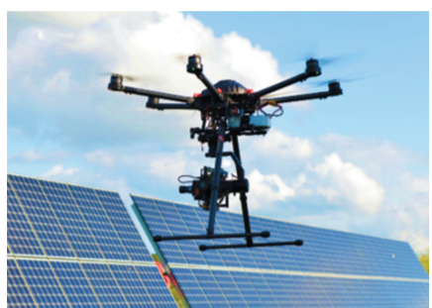

**Fig: 4 Drone with Raptor 640 SWIR camera.**

**2.2 Proposed Solution:**

To implement a solution for air pollution monitoring using Drone technology, we have to consider two main aspects. 1) Hardware configuration and 2) its control process. In our project we have designed our drone with multipurpose using different sensors. First of all, we thought in the context of Dhaka city. As the air of Dhaka is full of pollutant and we all know how many side effects it has, so our first step was to detect those pollutants from air, pollutants intensity of different area. We used GPS technology system so that our drone can perform automatically. Next step is to collect those data and analyses it. After analyzing data, we would know and compare the values where there is more pollutants which caused different hazards. So, clean the air our motive is to use air filter. As a result, our drone can automatically filter the air from toxic elements. We will use “Hepa mini”, a small air filter device. This drone can be used for research purpose and study of air quality. We used DJIF450 Quadcopter frame to build drone.

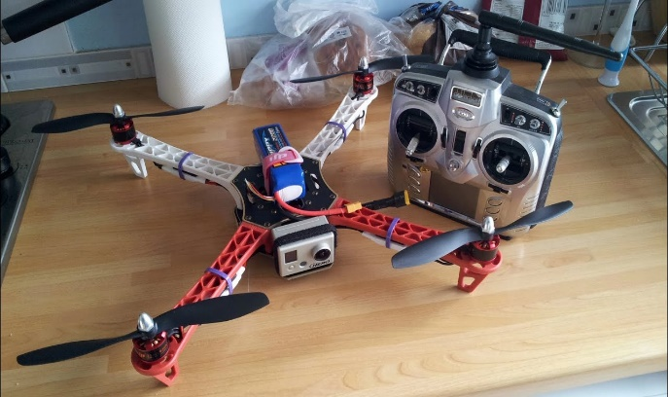

**Fig: 5 Drone**

By following these guides, our proposal can also be split into three parts.

1. Making Drone
2. Integrating Sensors and installation of pi cam
3. Analysing data.

**3.Technical Design**

**3.1 Workflow with explanation**

At first we assmbled our drone. Then we wired our senssors with this drone and connected all sensor with Arduino Uno. Uploaded the necessary codes and burned it. It properly worked. After that installed the camera with Raspberry pi. We connected GPS module so that automatically this drone can come back to its starting place. Finally after doing all this we successfully fly our drone.

Made a Drone

Raspberry pi

Integrating multiple sensors with pi cam

Fly Drone

Calibration of sensors with Arduino Uno

Calibration of drone with remote controller

Connecting GPS module

**Fig: 6 Work-Flow**

**3.2 Block diagram**

We have done our project upto building our drone and worked with the sensors. Data analyzing is our next step. We also add air filtration in our project.

Drone Building

Sensors and camera integration

Hepa Mini for air filtration

Pi Cam (Send Data (photos and videos) using a Wi-Fi module or Bluetooth 4.0 )

Computer

**Project Start**

Air pollution Specification

Sensor selection and detection

Server (cloud)

OpenCv

Data analysis and statistical report

Raspberry Pi for data transfer

End

**Fig:7 Total System concept for collecting data using drone mounted with multiple sensors.**

**3.3 Work Breakdown Details:**

We are working on this project as a team. Our work breakdown details from the very beginning of our senior design project given below. Here we divided the whole EEE499A week by week.

|  |  |  |
| --- | --- | --- |
| **Weeks** | **Detailed Work** | **Contributor** |
| **1** | * **Introduction to** Senior Design Project (EEE499A) * **Google research on several projects for making project proposal.** | **Everyone**  **Individual** |
| **2** | * Discussion about group formation & selecting project topic * Group finalized | -  - |
| **3** | * Group presentations on project proposals * Presentation slide submitted * Project topic & title selected:  **Drone** | everyone  everyone |
| **4** | * Individual Work entry on **github** initiated * Started studying several research paper on multifunctional Drone * Group meeting held * Started working on report Background/Literature review analysis * Analyze the functions and working principle of the components | Individual  Everyone  Everyone  Everyone  Everyone |
| **5** | * Continue working on github entry * Final required components list & cost/components list done * Group meeting on financial issues & collected fund from each member * Ordered essential components by online | Individual  Everyone  Everyone  Everyone |
| **6** | * Learn about technical design and proposed solution * Started to find out the reason of air pollution * Working on finding health issues of Air pollution * Finding the sensors that detects air pollution | Everyone  Everyone  Everyone  Everyone |
| **7** | * Learn about hardware, software, their limitations & fixing them * Start working on coding * Ordered essential sensors | Everyone  Everyone  **Everyone** |
| **8** | * Continue working on necessary coding * Finalize Circuit design * Group meeting held(online) | Everyone  Everyone  Everyone |
| **9** | * Finalized the necessary coding * Learnt necessary software * Made further adjustments of code needed | Everyone  Everyone  Everyone |
| **10** | * Start working on the final report * Gathered all the information needed for the report | Everyone  Everyone |
| **11** | * Waiting for the components * Continue work on the final report * **Start working on Drone building using Airsim** | Everyone  Everyone  Everyone |
| **12** | * Continue working on **Drone building using Airsim** * Make final presentation slide * Reviewing papers on **mind control drone** | Everyone  Everyone  Everyone |
| **13** | * **Components Received** * Finalize Report * Continue Reviewing papers on mind control drone | **Everyone**  Everyone  Everyone |
| **14** | * Started working on **Drone building** * Started reviewing papers on **Air Filtration** | Everyone  everyone |
| **15** | * Continue Working on Drone Building * Learnt About the Air filtration component **Hepa mini** | Everyone  everyone |
| **16** | * Finalize Drone Building * Fixing faced problems * Finalize report(Including Drone part) * Finalize presentation Slide * Started Working on **Hepa Mini** | Everyone  everyone  everyone  everyone  everyone |

**3.4 Components Financial Requirements:**

The cost of the project is financed by us. We already have some components like breadboard, wire box & battery. So we needed to buy only major components like Arduino, Respberri pi, Pi camera, & Drone components. Our total components cost is around 21k(that we bought). All the members of our group equally shared the components cost. We ordered the components from Rotor Solution bd.

**Table 2: Detailed component list with price**

|  |  |  |
| --- | --- | --- |
| **Components name** | **Quantity** | **Amount**  **(Tk)** |
| Arduino UNO R3  ARD-00028 | 1 | 410/- |
| Drone Components Package | 1 | 15000/- |
| Respberri Pi | 1 | 4000/- |
| Pi Camera | 1 | 1000/- |
| Hepa Mini | 1 | 700/- |
| Bread board | 1 | - |
| Wires | 1(box) | - |
| Soldering Iron | 1 | 350/- |

**4. Features with Design and description**

**4.1 Software requirements:**

**Arduino CC:**

For sensors calibration with drone we had used this software for burning codes and taking data.

**Fritzing:**

We used fritzing software for making circuit diagram of sensors wiring.

**Liberpilot:**

We used this software for calibrating our drone with the controller.

**Mission Planner :**

Mission Planner is a full-featured ground station application for the ArduPilot open source autopilot project.

**OpenCV People Counter:**

Using OpenCV, we’ll count the number of people who are heading “in” or “out” of a department store in real-time.

**4.2 Hardware description:**

A lot of different hardware’s were used in this project. Details of the hardware are given below.

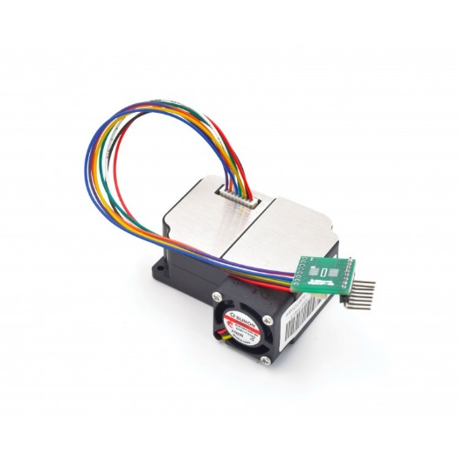

**Fig:8 PM sensor**

Track in real-time PM2.5 dust concentrations. It’s super easy to set up and start using right out of the box with our example Arduino code, along with pre-soldered headers and pre-connected wires. This high precision dust sensor can also be used to measure PM10 **in addition** to PM1.0.

**Features**

* Measure PM1.0 pollutant levels or below, down to 0.3um
* Accurate and stable data output
* Serial output
* Onboard fan
* Can connect it directly to a PC with a USB cable

**Specifications**

* measurable dust diameter: 0.3-1.0 um, 1.0-2.5um, 2.5-10um
* Data unit: ug/m3
* Resolution: 0.3ug/m3
* Range: 0-999ug/m3
* Response Time: less than 10s
* Operating Voltage and Current:  5V, 200mA,
* Sleep Model Current: 2mA
* Port: 3.3V TTL
* Module Dimension: 50.2x45.0x20.8mm

**Arduino Uno R3**

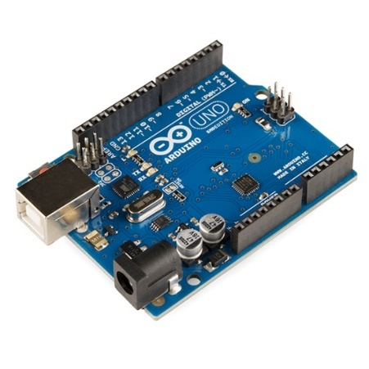

**Fig:9 Arduino Uno**

It is an open source microcontroller platform board used for building electronic projects, it is made using ATmega328p microcontroller, an 8-bit microcontroller with 32KB of Flash memory and 2KB of RAM. We simply connect the Arduino with a USB cable to the computer to get it started or use a battery.

**Advantages:**

* Really open source software and hardware
* Easy to learn
* Huge community
* Low cost boards and peripherals

**Disadvantages:**

* It's mostly still AVR (8-bit) "eco-system" (and +5 V). There is many claims that other (e.g. ARM) architecture are supported but you'll find pretty soon that even 32-bit boards designed by Arduino team (e.g. Due, Zero, MKR) are not supported in a similar way to 8-bit (Uno, Leonardo, Mega2560): they are still second choice
* If we need more processing power and working memory, we will have to move on to other implementation.

**DJI 2212 920KV Brushless Motor for Drone**

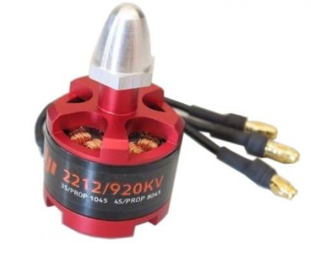

**Fig: 10 Motor**

920Kv Brushless DC Motor is a Brushless DC electric motor (BLDC motors, BL motors) also known as electronically commutated motors (ECMs, EC motors) are synchronous motors that are powered by a DC electric source via an integrated inverter switching power supply, which produces an AC electric signal to drive the motor.

**Features of DJI 2212 920KV Brushless Motor:**

* KV(rpm/v): 920.
* Max Power: 370W.
* Max Thrust: 1200 grams.
* Weight: 53 grams.
* Shaft Diameter: 4mm.
* Shaft Length: 49mm Recommended Propeller for battery: 12x4.5 for 2S battery; 10x4.5 for 4S battery.
* Battery: 2S-3S Li-Po.
* ESC (A): FMT 30A (recommended).

**DJI F450 Frame**

**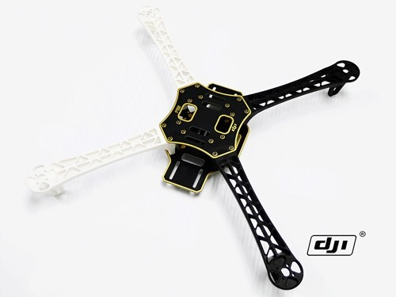**

**Fig:11 DJI F450 Frame**

DJI F450 Frame Wheel QuadCopter frame is designed for all pilots for fun or with the use of an autopilot.

The DJI F450 Flame Wheel frames are built from very strong materials, the arms are made from the ultra strong PA66+30GF material which provides better resistance to damage on hard landings, while the main frame plates use a high strength compound PCB material, which makes wiring of ESCs and battery easy and safe on the lower of the two frame plates which is also the power distribution board.

|  |  |
| --- | --- |
| **Frame** | F450 Flame Wheel |
| Diagonal Wheelbase | 450mm |
| Frame Weight | 282g |
| Takeoff Weight | 800g ~1600g |

**Ardupilot APM 2.8 Flight Control Board Bend Pin with Protective Case**

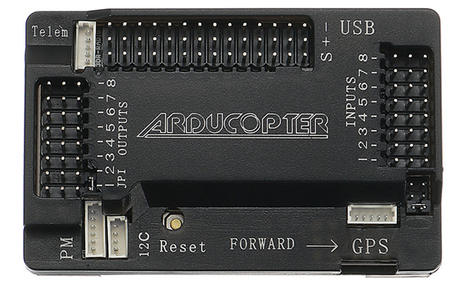

**Fig:13 Ardupilot**

**Specification:**  
Item Name: APM 2.8 Flight Control Board

**Features:**

Compatible!

Includes 3-axis gyro, accelerometer, along with a high-performance barometer

Onboard 4 MegaByte Dataflash chip for automatic datalogging

Optional off-board GPS, LEA-6H module with Compass.

One of the first open source autopilot systems to use Invensense's 6 DoF Accelerometer/Gyro MPU-6000.

Barometric pressure sensor upgraded to MS5611-01BA03, from Measurement Specialties.

Atmel's ATMEGA2560 and ATMEGA32U-2 chips for processing and usb functions respectively.

**GPS- Neo-7**

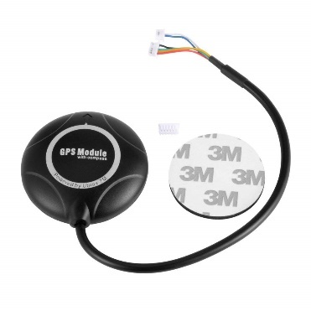

**Fig: 14 GPS- Neo-7**

Ublox Neo 7M GPS module that includes an **HMC5883L digital compass.**  The new **Ublox NEO 7 series** is a high sensitivity, low power GPS module that has 56 channels and outputs precise position updates at 10Hz.  This GPS module also comes with a molded plastic case which keeps the module protected against the elements making it ideal for use on your aircraft or quadcopter.

#### *****Features:*****

1. Locate performance
2. These are Pre-configured, flashed with the correct settings, and tested. To make them Plug and Play.
3. Super Bright LED
4. Backplane with Standard Mk style mounting holes 45mm X 45mm
5. 38400 bps (Default) Changed to 115200bps!
6. Output GGA, GSA and RMC frames
7. 1Hz (Default) Changed to 5Hz!
8. Permanent Configuration Retention
9. compass on board
10. 6 pin connectors for EZ connect to MEGA BLACK
11. 4 pin connectors for only GPS use
12. 4 pin connectors for compass only use
13. Can use both 4 pins at once.

**Lipo Battery 2200mAh / 11.1V**

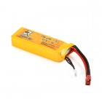

**Fig: 15 Lipo Battery 2200mAh / 11.1V**

**Lipo Battery 2200mAh / 11.1V**has three cells and outputs 11.1V storing 2200mAh of charge.This is a good Li-po battery for projects like small robotics and radio-controlled projects. It has high discharge rates and big capacity and can be used in RC airplane, RC helicopter, RC car, RC truck, RC boat, drone applications. This high-power output battery has very special internal structure, which requires dedicated balance charger to charge. Li-Poly Battery Charger is a suitable mate. iMAX-B6AC Battery Charger can be used to recharge this module.

**Specifications of Lipo Battery 2200mAh / 11.1V**

* Material: Li-polymer
* Battery voltage: 11.1 V
* Nominal capacity: 2200mAh
* Max. Charge current: 2.2A
* Discharge: 25C
* Wire length: 50 ± 5mm
* Cell: 3S

### Robocraze Fly sky CT6B Remote 6 Channel Transmitter and Receiver for Quadcopter RC-A-004

### 

**Fig:16 Remote**

This transmitter requires a PC to modify any of the channel variables, including mixing and servo reversing.

This is FS-CT6B 6ch 2.4GHz transmitter & receiver It has 0.8W transmitter with range up to 1km line of sight. Specifications: Channels: 6. Frequency: 2.4GHz.

##### Features:

* Channels: 6 Channels
* Model Type: Heli, Airplane, Glid
* RF Power: Less than 20db
* Modulation: GFSK
* Code Type: 2.4Ghz No Interference

**The Raspberry Pi**

* The Raspberry Pi is a series of small single-board computers developed by the Raspberry Pi Foundation.
* [Power](https://www.google.com/search?q=raspberry+pi+power&sa=X&ved=2ahUKEwiVodfM-p7pAhX363MBHRGuBZgQ6BMoADAuegQICRAC): 5V 3A (for full power delivery to [USB](https://www.google.com/search?q=USB&stick=H4sIAAAAAAAAAONgVuLQz9U3MC9PTlvEyhwa7AQAFmp7qRIAAAA&sa=X&ved=2ahUKEwiVodfM-p7pAhX363MBHRGuBZgQmxMoATAuegQICRAD) devices)
* [Storage](https://www.google.com/search?q=raspberry+pi+storage&sa=X&ved=2ahUKEwiVodfM-p7pAhX363MBHRGuBZgQ6BMoADAvegQIChAC): MicroSDHC slot
* [Memory](https://www.google.com/search?q=raspberry+pi+memory&sa=X&ved=2ahUKEwiVodfM-p7pAhX363MBHRGuBZgQ6BMoADAwegQICxAC)**:**1, 2, or 4 GiB LPDDR4-3200 RAM

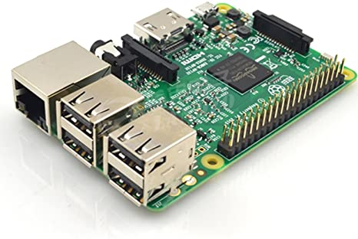

**Fig :17 The Raspberry Pi**

**Pi Cam:**

* The Raspberry Pi Camera v2 is a high quality 8 megapixel Sony IMX219 image sensor custom designed add-on board for Raspberry Pi, featuring a fixed focus lens. 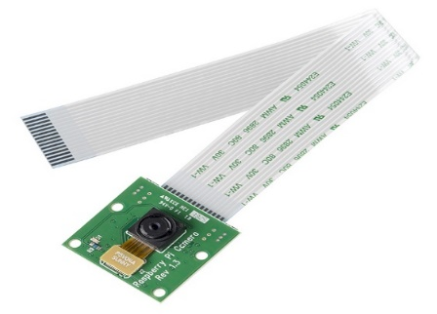

**Fig: 18 Pi Cam**

**Wi-Fi Module:**

* The ESP8266 WiFi Module is a self contained SOC with integrated TCP/IP protocol stack that can give any microcontroller access to your WiFi network.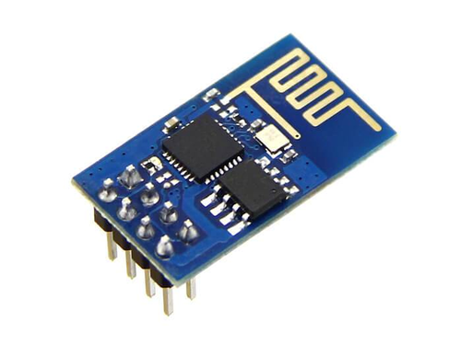

**Fig:19 Wi-Fi Module.**

**MQ-2 (gas sensor)**

* MQ2 gas sensor is an electronic sensor which is used for sensing the concentration of gases in the air such as LPG, propane, methane, hydrogen, alcohol, smoke and carbon monoxide. this sensor is also known as chemiresistor. In this sensor there is a sensing material whose resisteance changes when it senses gas.

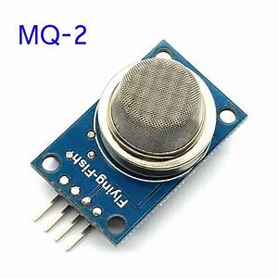

**Fig: 20 MQ-2 gas sensor.**

**MQ135 (gas sensor)**

* The MQ-135 Gas sensors are used in air quality control equipment and are suitable for detecting or measuring of NH3, NOx, Alcohol, Benzene, Smoke, CO2.

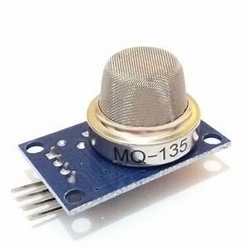

**Fig:21 MQ-135 gas sensor.**

**Mq-7 (gas sensor)**

* Any signal when the sensor is shifted from clean air to carbon monoxide (CO), output signal measurement is made within one or two complete heating period (2.5 minute from high voltage to low voltage). Sensitive layer of MQ-7 gas sensitive components is made of SnO2 with stability, So, this sensor long term stability.

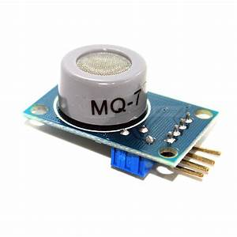

**Fig:22 MQ-135 gas sensor.**

**4.3 Circuit Diagram(sensors)**

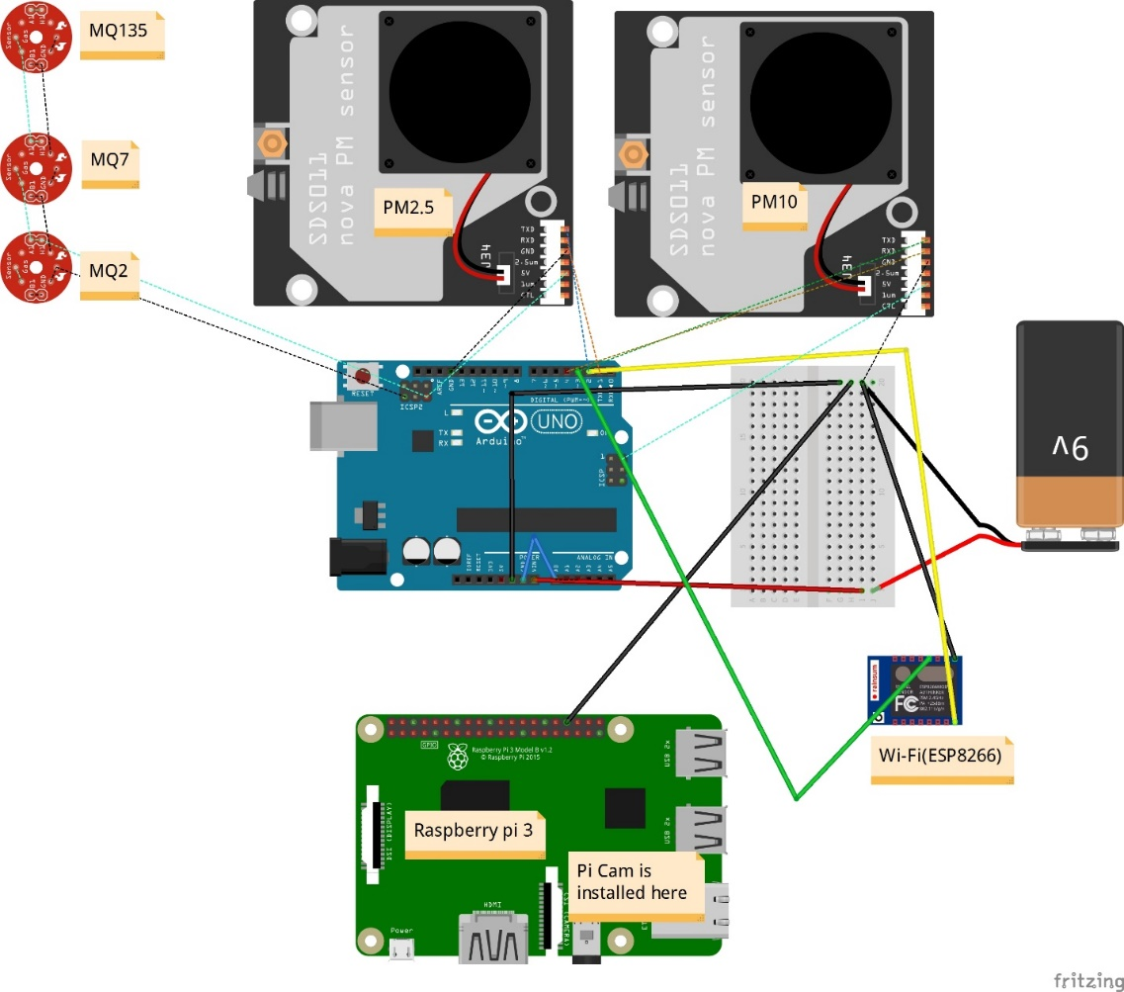

**Fig: 23 Circuit Diagram.**

We have made this circuit diagram with the help of fritzing software. Here we connected all the sensors with Arduino and installed pi cam, for sending data we sending data we used Wi-Fi module. All labels are given.

**4.4Circuit layout:**

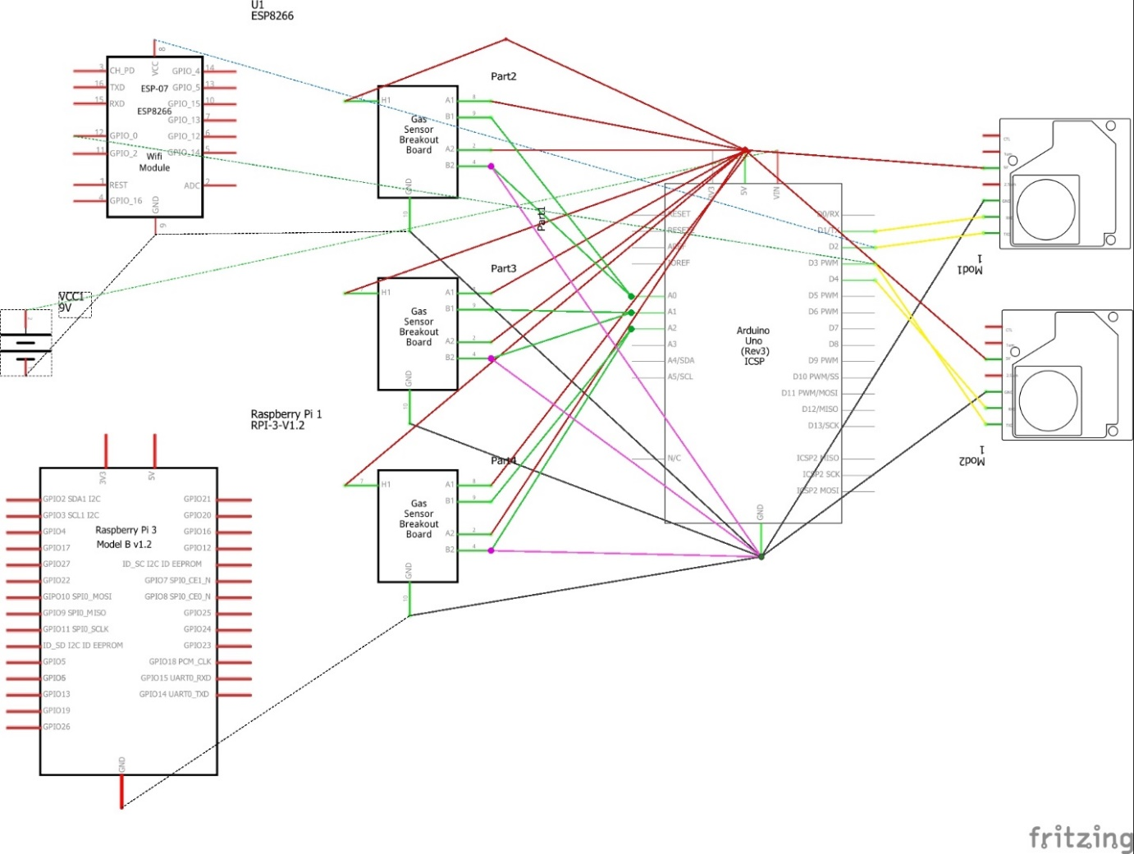

**Fig: 24 Schematic Diagram(sensors)**

**4.5 Circuit Diagram(Drone)**

**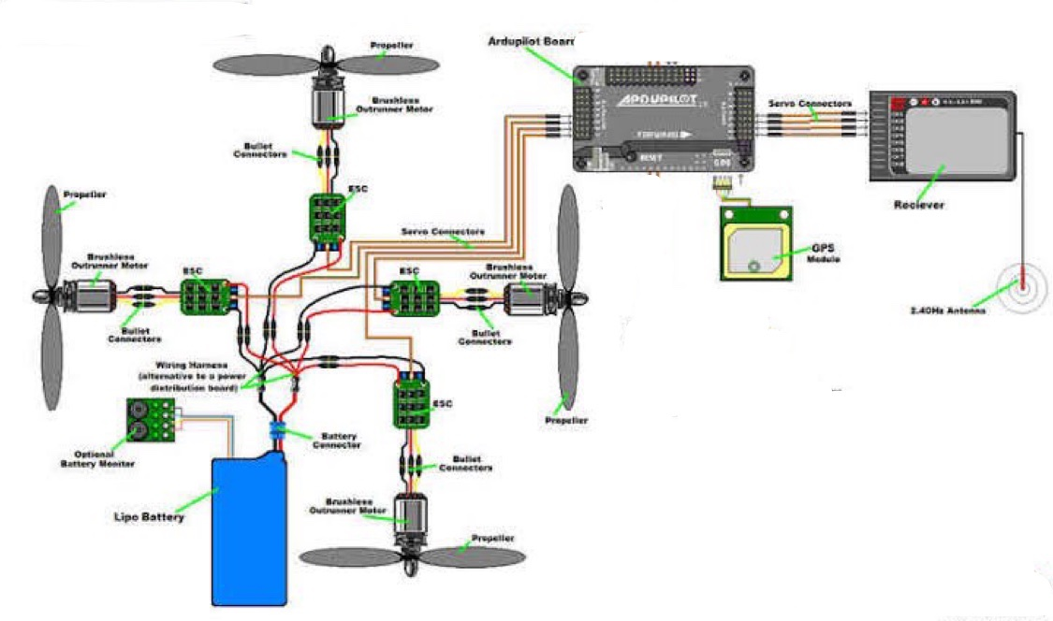**

**Fig: 25 Schematic Diagram(Drone)**

We have followed this diagram while making our drone. Steps of our Drone Building given Below:

**5. Result and Discussion:**

**5.1 Steps Of Drone Building:**

We first gathered all the necessary components and supporting tools together.

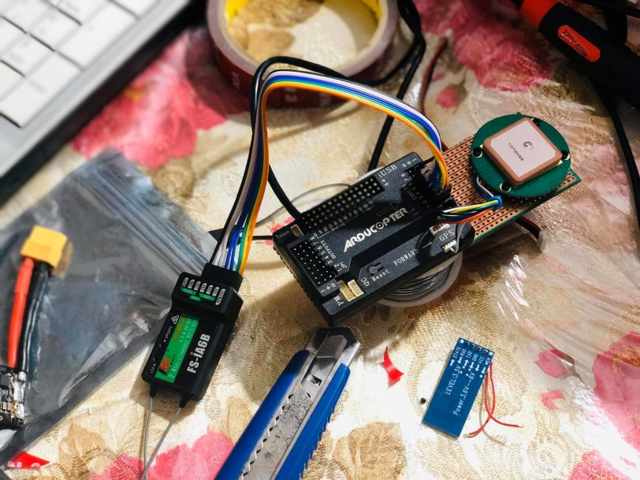

**Fig:26 RC connection**

This is Rc connection with transmitter to receiver. Transmitter to receiver communicates via 2.4Ghz. 6 individual channel, means 6 separate PWM value.

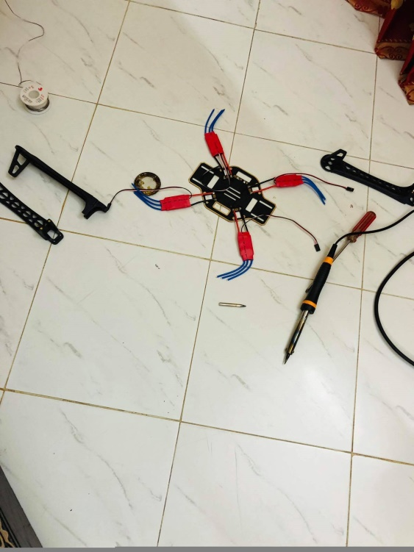

**Fig:27 Body construction**

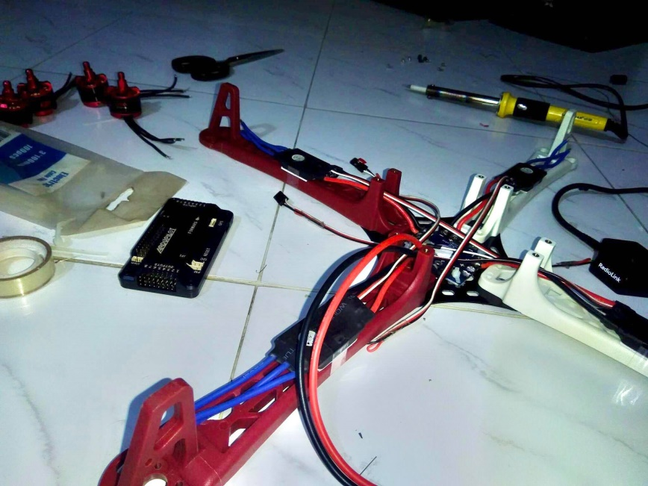

**Fig:28 Body Construction(2)**

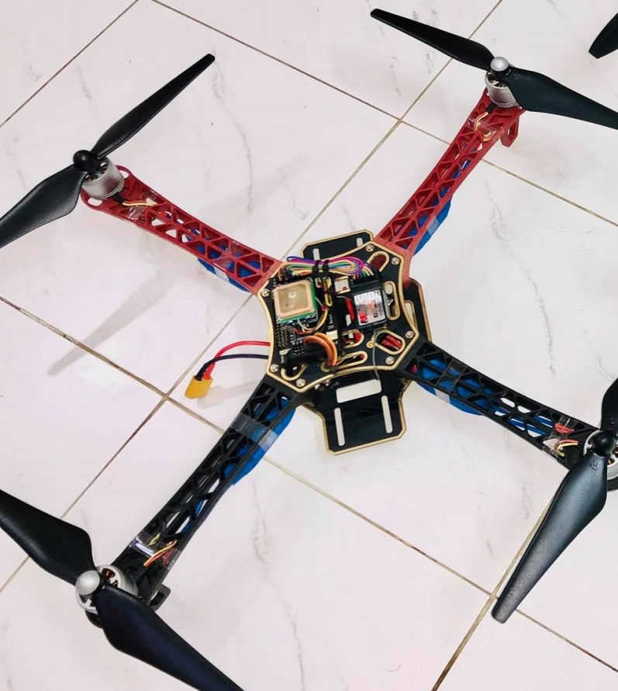

**Fig: 29 Complete Drone**

**5.2 Discussion:**

We've done building our drone in EEE499A. Still, We didn't integrate the sensor part with the drone. We are practicing over it, recording the challenges and the limitations of it. Per motor draws 2A while hovering. So 4 motor draws 8A for hovering in the air. Our selected battery is 2.2Ampere/hour. That means it can delivery 2.2A for 1 hour (60minutes).

The calculation,

2.2A delivers 60 minutes 1A delivers 60x2.2 minutes 8A delivers (60x2.2)/12 minutes =16.5 minutes (theoretically, moderate air condition) Practically it varies from 12-14 minutes.

Theoretically, the range of our drone is 1KM, but practically it varies from 600-800 meters depending on the weather. Transmitter to the receiver has to communicate via 2.4Ghz. 6 individual channel, means 6 separate PWM values. But technically it shows some variations. Usually, we use  'mission planner' from the laptop or 'Droid planner' from mobile to select the specific path for the Drone, But in case of an error, we alternatively use a remote to control The drone. We give the input from Mobile/Laptop then it flies accordingly and returns at the same place.

We use Soldering iron, Screw box, Hex screw, Double side tape as supporting tools.

**5.3 Future Work** **(EEE499B):**

We will finish all of our unfinished work during EEE499b. Our plan for the EEE499B given below:

* We will integrate the sensor part with the drone and analyze the air quality to detect Pollutants.
* We will integrate Hepa Mini with the Drone to filter the Air
* We will analyze all the collected data and will give a statistical analysis of that.
* Finally we will come up a complete solution with our given model(Detecting Air pollutants, Collecting data for statistical analysis, Structural Views, And finally Air filtration)

**5.3 Conclusions and recommendations**

Air pollution in Dhaka is a high priority concern as it is seriously affecting the quality of life in the city and represents a major public health issue. Although pollutants emitted from the transport sector clearly constitute the major pollution problem in Dhaka, no emission inventory detailing sources of pollution is currently available. Emissions in metropolitan Dhaka have been increasing at a steady rate for more than three decades. Annual average increases of 6.5% in NOx, 5.8% in HC, 5.9% in CO, 5.6% in PM and 6% in Sox. In our project we try to measure the percentage of the pollution and would compare the results that a person could hold in his body. Although there is a lack of time-series data, the air quality measurements available indicate that Dhaka’s air pollution is worsening.

# 

# 5.4 Acknowledgements

We take great pleasure and contentment in submitting our senior design project report on “**Air quality monitoring for detecting pollutants and Auto filtration with Drone Technology**”. This report is prepared as a requirement of the Capstone Design Project CSE/EEE/ETE 499 A, which is a two semester long senior design course followed by CSE/EEE/ETE 499 B. This course involves teams of students who build and test custom designed systems or engineering processes.

Thus, we are extremely grateful and would like to express our profound gratitude for our honorable course instructor for his constant and meticulous supervision, suggestions and encouragement for us to complete our project for this course. We would also like to thank the Electrical and Computer Engineering Department of North South University for providing us with the opportunity of doing such a course under such great supervision in our undergraduate program.

# 6.References

.

1. https://ardupilot.org/planner/docs/common-loading-firmware-onto-pixhawk.html
2. <https://solarimpulse.com/air-pollution-solutions?utm_term=effects%20of%20air%20pollution&utm_campaign=Solutions&utm_source=adwords&utm_medium=ppc&hsa_acc=1409680977&hsa_cam=1418806209&hsa_grp=61846220619&hsa_ad=309871224659&hsa_src=g&hsa_tgt=kwd-14671731&hsa_kw=effects%20of%20air%20pollution&hsa_mt=b&hsa_net=adwords&hsa_ver=3&gclid=EAIaIQobChMIhtKzwf696gIVwRwrCh3gkgBmEAAYASAAEgJi8_D_BwE>
3. <https://www.azocleantech.com/article.aspx?ArticleID=791>
4. [**https://www.unmannedsystemstechnology.com/wp-content/uploads/2019/10/MicaSense-DualCam-Multispectral-Drone-Imaging-Solution.jpg**](https://www.unmannedsystemstechnology.com/wp-content/uploads/2019/10/MicaSense-DualCam-Multispectral-Drone-Imaging-Solution.jpg)
5. [**https://www.unmannedsystemstechnology.com/wp-content/uploads/2020/01/TEN-TECH-LLC-Hurac%C3%A1n-Multi-Purpose-Aerial-Drone.jpg**](https://www.unmannedsystemstechnology.com/wp-content/uploads/2020/01/TEN-TECH-LLC-Hurac%C3%A1n-Multi-Purpose-Aerial-Drone.jpg)
6. [**https://i.ytimg.com/vi/SWjII7mxaZg/maxresdefault.jpg**](https://i.ytimg.com/vi/SWjII7mxaZg/maxresdefault.jpg)
7. https://ardupilot.org/copter/docs/common-installing-3dr-ublox-gps-compass-module.html?highlight=apm&fbclid=IwAR0XM-1QwuZ\_2ea-MmPlqLpKJpTg6Hamh3l5Wh2G50ZXW2RbCLD8qwE3Cp0